READING 1
Exercises
Task 1. Read the article “International Students” (pages 5-6) in your coursebook and answer the questions.
- What are international students?
…………………………………………………………………………………………
- What is postsecondary?
…………………………………………………………………………………………
- Which country do most international students go to school?
…………………………………………………………………………………………
- Why do students attend colleges/ universities far from home?
………………………………………………………………………………………....
- Why do institutions of higher education want foreign students?
………………………………………………………………………………………....
Task 2. Read the article “University Life Around The World” (pages 11-13) in your coursebook and answer the questions.
- What are the similarities and differences of universities around the world?
………………………………………………………………………………………………
- What do students in most of countries around the world get after some years of study?
………………………………………………………………………………………………
- In some Asian or Middle Eastern countries, how does the exit exam classify the students?
………………………………………………………………………………………………
- There are 2 kinds of classroom atmosphere? What are they?
………………………………………………………………………………………………
- What are some common activities carried out when students work in groups?
………………………………………………………………………………………………
- What are some facilities and services available to students at college and university campuses around the world?
………………………………………………………………………………………………
Task 3. Read the article “International Students” (pages 5-6) in your coursebook and fill in the gaps.
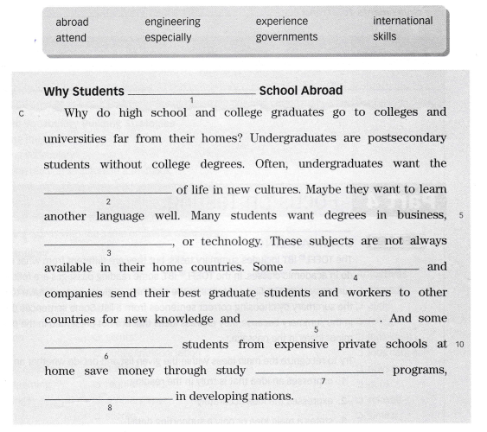
Task 4. Match each vocabulary on the left with the correct defintion on the right. The vocabulry words are from the article “University Life Around The World” (pages 11-13). The letter in parentheses ( ) are the letters of the paragraphs.
